AGENDA |   SCHOOLS FORUM  Distribution  Members of the Committee  Appropriate Officers attending:  Mustafa Salih  Hilary Smith  Caroline Warren  Alison Davies  Councillors attending:  Erica Williams  Trevor Jones  Director for Children, Adults and Health, Badminton Road Offices, Yate, South Gloucestershire, BS37 5AF  Telephone: (01454) 863253  Enquiries to : Mustafa Salih, Head of Financial Management and Business Support, Telephone (01454) 862548 or E-mail mustafa.salih@southglos.gov.uk  .
  Date: | Thursday 21st January 2021
  Time: | 4.30pm
  Place: | Microsoft Teams
  Sarah Lovell (Chair) | Dave Baker (Vice Chair)
  Bernice Webber | Louise Leader
  Nicky Edwards | Pippa Osborne
  Mark Freeman | Diane Owen
  Kim Garland | Lisa Parker
  Clare Haughton | Will Roberts
  Steve Moir | Susie Weaver
  Richard Aquilina | Susan Brobyn
  Carl Lander | Malcolm Strange
  Kirby Littlewood | Stuart Evans
  Julia Anwar (Sub) | Louisa Wilson
  Linda Porter | Nicki Jones
  David Jenkins | David Williams

Public Rights to Information and Attendance at Meetings

YOU HAVE A RIGHT TO:

Attend all Council, Committee and Sub-Committee meetings unless the business to be dealt with would disclose ‘confidential’ or ‘exempt’ information.
Inspect agendas and public reports five days before the date of the meeting.
Inspect agendas, reports and minutes of the Council and all Committees and Sub-Committees for up to six years following a meeting.
Inspect background papers used to prepare public reports for a period of up to four years from the date of the meeting. (A list of background papers to a report is given at the end of each report). A background paper is a document on which the officer has relied in writing the report.
Have access to the public register of names, addresses and wards of all Councillors with details of the membership of all Committees and Sub-Committees.
Have a reasonable number of copies of agendas and reports (relating to items to be considered in public) made available to the public attending meetings of the Council, Committees and Sub-Committees.
Have access to a list setting out the decision making powers the Council has delegated to their officers and the title of those officers.
Copy any of the documents mentioned above to which you have a right of access. There is a charge of 15p for each side of A4, subject to a minimum charge of £4.
For further information about this agenda or how the Council works please contact Mustafa Salih (01454) 862548 or e-mail mustafa.salih@southglos.gov.uk
Also see our website www.southglos.gov.uk

EMERGENCY EVACUATION PROCEDURE

In the event of a fire alarm, fire drill or other emergency, signalled by a continuously ringing bell, please leave from the room via the signs marked “Exit”.

OTHER LANGUAGES AND FORMATS

This information can be made available in other languages, in large print, Braille or on audio tape. Please phone (01454) 868686 if you need any of these or any other help to access Council services.
AGENDA

1 | WELCOME AND INTRODUCTIONS
2 | APOLOGIES FOR ABSENCE (Sarah Lovell)
3 | DECLARATIONS OF INTEREST (Sarah Lovell)
4 | SCHOOLS FORUM MEMBERSHIP (Ali Davies)
5 | ANY OTHER ITEMS THE CHAIR DECIDES ARE URGENT (Sarah Lovell)
6 | MINUTES FROM 19 NOVEMBER 2020 (Sarah Lovell)
7 | LOCAL RESPONSE TO PANDEMIC (VERBAL) (Hilary Smith)
8 | GROWTH FUNDING POLICY (Caroline Warren)
9 | Q2 UPDATE (Caroline Warren)
10 | EARLY YEARS FUNDING (NFF FUNDING RATES FOR 2021/22) (Rachel Webb) (Update paper on consultation to follow w/c 18/01/21)
11 | INTERNAL AUDIT FEEDBACK FROM ACADEMIES (Sarah Lovell)
12 | HNWG UPDATE (Susie Weaver)
13 | SCHOOLS FORUM FORWARD PLAN
14 | ANY OTHER BUSINESS

SOUTH GLOUCESTERSHIRE COUNCIL
SCHOOLS FORUM
21 January 2021
Schools Forum Membership Update

Purpose of Report

- The purpose of the report is:

- To provide an update to the Forum on membership
- Provide a revised membership list subject to new members being approved at the meeting
- To ensure that the Schools Forum is representative and quorate

Background

- The latest membership list published on our Schools Forum page is dated November 2019. There have been several changes since then, which this paper updates the Forum on. A revised list is attached to this paper at Annex 1.

- At October’s meeting, we updated on 2 members who were coming to the end of their terms of office. We also had 3 members who had not attended 3 or more meetings, and 1 Diocesan vacancy. This paper provides an update on all of these.

Renewal of terms of office

- Our Chair, Sarah Lovell’s term of office ended on 1 December 2020, with 3 months to renew or hold elections. As Sarah wished to renew her term as Academies representative, the relevant groups were emailed to see if anyone else wished to be considered. All agreed with renewing Sarah’s term and it is proposed that this will therefore run until 1 December 2024.

- Lisa Parker’s term of office as the representative for Special Schools came to end on 3 December 2020, again with 3 months to renew or hold elections. Lisa had previously confirmed that she would be happy to remain as the rep if no one else self-nominated. The process for self-nomination in this sector was undertaken, with no responses received. Therefore it is proposed that Lisa’s term is renewed until 3 December 2024.

Primary Headteacher membership

- 2 primary headteachers had been unable to attend for 3 subsequent meetings and have now resigned their membership.

- As a result, a self-nomination process was held for primary head teachers in conjunction with the head teacher’s executive group. As 2 self-nominations were received, the group confirmed Kirby Littlewood and Louisa Wilson as the 2 new representatives. It is proposed that her term of office will run from this meeting date for four years.

Special Academies Headteacher/Headteacher Representative or Governor membership

- The previous representative from this sector resigned and therefor was no longer eligible to me a member of the Forum.

- Prospective members were contacted and Nicki Jones self-nominated. It is proposed that their terms of office will run from this meeting date for four years.

Diocesan Vacancy

- Our Forum membership of the forum is had been set at 24 of the recommended 25 with one Diocesan vacancy. The relevant diocese were contacted and David Williams of the Gloucester diocese self-nominated. It is proposed that his term of office will run from this meeting date for four years.

Substitution Vacancies

- We have vacancies in our ‘substitutions members’ for:
- 1 x Governor from Maintained Primary
- 1 x Member Representative from Special Academy

- These posts do not affect the core membership of the Forum. Any recruitment for these will be taken forward over the coming months.

RECOMMENDATIONS

- Confirm term of office renewals for Sarah Lovell and Lisa Parker.

- Approve membership for Louisa Wilson and Kirby Littlewood as Primary headteacher representatives.

- Approve Nicki Jones as Special Academies representative.

- Approve David Williams as the second Diocesan representative.

- Agree that a revised membership list as at Annex 1 can be published on the Schools Forum webpage.

Report Author
Ali Davies, Business Support Manager

Annex 1 - Forum membership – updated at January 2021 4
Type & number of Members | No | Sub-Group Represented | Forum Representative | Establishment | Term of Office/Position
Maintained school members (5 Primary Headteachers/4 Primary Governors/1 Secondary/1 Special/1 PRU representative) = 12
Primary | 1 of 5 | Headteacher/Headteacher Representative | Bernice Webber | Headteacher, Old Sodbury CE Primary | 23/01/2020
Primary | 2 of 5 | Headteacher/Headteacher Representative | Mark Freeman | St Michael’s CE VC Primary | 19/09/2019 (2nd term)
Primary | 3 of 5 | Headteacher/Headteacher Representative | Kirby Littlewood | Stanbridge Primary School | 21/01/21
Primary | 4 of 5 | Headteacher/Headteacher Representative | Pippa Osbourne | Christ Church CofE School | 01/01/2019
Primary | 5 of 5 | Headteacher/Headteacher Representative | Louisa Wilson | St. Stephens C of E Junior School | 21/01/21
Primary | 1 of 4 | Governor | Linda Porter | Governor-Watermore School | 18/07/2019
Primary | 2 of 4 | Governor | David Jenkins | Governor – Crossways Schools | 18/07/2019
Primary | 3 of 4 | Governor | Richard Aquilina | Bailey’s Court Primary | 19/10/2019
Type & number of Members | No | Sub-Group Represented | Forum Representative | Establishment | Term of Office/Position
Primary | 4 of 4 | Governor | Carl Lander | Hanham Primary Federation (HPF) | 19/10/2019
Secondary | 1 of 1 | Headteacher/Headteacher Representative or Governor | Kim Garland | Headteacher-Brimsham Green | 18/07/2019 (2nd term)
Special Schools | 1 of 1 | Headteacher/Headteacher Representative or Governor | Lisa Parker | Headteacher Warmley Park | 21/01/21 (2nd term)
PRU (only has to be 1) | 1 of 1 | Headteacher/Headteacher Representative or Governor | Louise Leader | Headteacher Pathways Learning Centre | 18/07/2019 (2nd term)
Academies members (1 Primary/1 Special/6 Secondary member representatives) = 8
Primary Academy | 1 of 1 | Headteacher/Headteacher Representative or Governor | Susie Weaver | Executive Principal CLF | 19/09/2019 (2nd term)
Special Academy | 1 of 1 | Headteacher/Headteacher Representative or Governor | Keith Lawrence  No longer in post 09/07/20 | Chair of Enable Trust. | 19/09/2019 (2nd term)
Secondary Academy | 1 of 6 | Headteacher/Headteacher Representative or Governor | Susan Brobyn | CSET Director of Finance & Operations | 21/11/2019
Secondary Academy | 2 of 6 | Headteacher/Headteacher Representative or Governor | Dave Baker (Vice Chair) | CEO OAT | 19/09/2019 (2nd term)
Type & number of Members | No | Sub-Group Represented | Forum Representative | Establishment | Term of Office/Position
Secondary Academy | 3 of 6 | Headteacher/Headteacher Representative or Governor | Diane Owen | Chair to Academy Council at King’s Oak Academy | 14/09/2017
Secondary Academy | 4 of 6 | Headteacher/Headteacher Representative or Governor | Sarah Lovell (Chair) | Finance Director  CLF | 21/01/21 (2nd term)
Secondary Academy | 5 of 6 | Headteacher/Headteacher Representative or Governor | Will Roberts | CEO CSET | 01/03/2019
Secondary Academy | 6 of 6 | Headteacher/Headteacher Representative or Governor | Steve Moir | Headteacher – Bradley Stoke | 18/07/2019
Non-school members
16-19 | 1 of 1 | Representative | Steve Evans – SGS Filton | SGS | 01/09/2019
Early Years | 1 of 2 | Representative | Nicky Edwards | ncn ltd | 01/05/2017
Early Years | 2 of 2 | Representative | Clare Haughton | Page Park Pre-school | 14/09/2017
Diocese | 1 of 2 | Representative | Malcolm Strange | Diocese of Bristol | 18/10/2019
Diocese | 2 of 2 | Representative | David Williams | Diocese of Gloucester | 21/01/21

Type & number of Members | No | Sub-Group Represented | Forum Representative | Establishment | Term of Office/Position
Substitutions
Maintained Primary | 1of1 | Headteacher | Katherine Marks | Headteacher  Frenchay Primary | Katherine.Marks@frenchayprimary.org.uk
Maintained Primary | 1 of 1 | Governor
Maintained Secondary | 1 of 1 | Member Representative | Terry Redfern/Stuart Thomas | Business Manager/AHT Brimsham Green | tredfern@brimsham.com SThomas@brimsham.com
Maintained Special School | 1 of 1 | Member Representative | Tania Craig | Head teacher New Horizons | t.craig@nhlc.org.uk
Pupil Referral Unit | 1 of 1 | Member Representative | Dan Walton | Deputy Head PLC | Daniel.walton@pathwayslearningcentre.org
Primary Academy | 1 of 1 | Member Representative | Sue Kelham | Principal Wallscourt Farm | suekelham@wfa.cabot.ac.uk.
Special Academy | 1 of 1 | Member Representative
Secondary Academy | 1 of 1 | Member Representative | Julia Anwar | Head of Finance - OAT | julia.anwar@olympustrust.co.uk

South Gloucestershire Schools Forum
Minutes of Meeting held on
Thursday 19 November 2020
Microsoft Teams
PRESENT:

Sarah Lovell (Chair) Finance Director, Cabot Learning Federation
Dave Baker (Deputy Chair)CEO, Olympus Academy Trust
Terry Redfern (rep for Kim Garland) Headteacher, Brimsham Green
Pippa Osborne Headteacher Christ Church Junior School
Nicky Edwards Natural Choice Nurseries
Diane Owen Chair, King’s Oak Academy
Stuart Evans South Gloucestershire and Stroud College
Fr. Malcolm Strange Diocese Rep
Steve Moir Headteacher, Bradley Stoke
Susie Weaver Executive Headteacher, Cabot Learning Federation
Carl Lander Hanham Primary Federation (HPF)
Louise Leader Headteacher, Pathways Learning Centre
Linda Porter Governor, Watermore School
Lisa Parker Headteacher, Warmley Park School
Susan Brobyn Director of Finance & Operation, CSET
Bernice Webber Headteacher, Old Sodbury CE Primary
Will Roberts CEO, Castle School Education Trust (CSET)

Officers:

Mustafa Salih, Head of Financial Management and Business Support
Hilary Smith, Head of Education, Learning and Skills
Caroline Warren, Finance Business Partner
Michelle Palmer, Senior Finance Officer
Alison Davies, Business Support Manager

- WELCOME AND INTRODUCTIONS

Attendees were welcomed by the Chair.

- APOLOGIES FOR ABSENCE
Trevor Jones, Clare Haughton, David Jenkins, Richard Aquilina

DECLARATIONS OF INTEREST - None

- ANY OTHER ITEMS THE CHAIR DECIDES ARE URGENT

None

- SCHOOLS FORUM MEMBERSHIP

Three people have left Schools Forum and we have gone out for nominations for those posts.

Two posts coming to the end of term. A couple of amendments for schools and once updated will publish a new list on the website.

2 vacancies for Primary Maintained Headteachers, to be discussed at the Heads’ Executive meeting next Friday.

- MINUTES FROM LAST MEETING – 20 OCTOBER 2020

Action: MS to share the dates of the forthcoming Governor Consultation meetings. Done

Action: MS to review the formula in more detail as to why some schools have benefited and others have not.

MS - We went through the calculations in quite detail and all the calculations were correct.

CW – Gave an explanation of the calculations as it looked like the all-through schools were getting back more than primary or secondary and having gone through it, the formula is correct.

SL – Thank you for confirming the formula is accurate and has been applied

Diane Owen to be removed from the list of attendees for the October meeting as she had sent apologies for the meeting.

Confirmed remainder Minutes were an accurate reflection of the meeting.

- SCHOOLS BUDGET CONSULTATION - OPTIONS

MS – Not able to email a formal report out but did share the consultation responses for the Forum Members to review ahead of the meeting.

MS produced slides for the Forum.

Following the consultation process we are seeking a formal view from the Schools Forum for the disapplication to be sent out tomorrow to the secretary of state.

The disapplication request will be based on Schools Forum views tonight. We then wait until probably the end of December for our actual Dedicated Schools Grant (DSG) figures and National Funding Formula (NFF) is released, which will allow us to start setting the schools budgets for 2021/22 and hopefully we would have heard from the Secretary of State by 21st January when we meet again as a Forum. If not approved by the SoS, we will need to bring some other options back to the Schools Forum.

It will go to Cabinet first and get approved at Full Council on 10th February. By 28th February 2021 we would need to have sent all schools their budget allocations.

Consultation outcomes – I presented the Options at 2 governor sessions which were very well attended and there was quite a lot of engagement. I also presented at Secondary and Primary Heads’ groups. Based on the terms of the consultation, it was a quite clear cut response.

Out of 117 schools, 87 responded.
- 84% were in favour of Option 2, the Council’s preferred Option to transfer £2.2m and matches the Schools Forum recommended Option from the previous meeting.
- 14% in favour of Option 3.
- 2% in favour of Option 1.

Feedback comments from schools were included in the email, some challenging comments asking for more clarification of the work we are doing improving the SEND system. Recognise work needed to be done in that area and will be discussed at HNWG to talk about what we are doing is positive and will lead to change in figures.

£2.2m to support pupil places to make sure we continue the cluster funding – some support for schools to allow them for residential savings. Some funding into the early years sector as we know that the earlier we can intervene and give some support for our special schools to meet specialist need and not drift to residential places the better.

Schools Forum to make a formal approval of that recommendation.

MS - We do need to work on the cluster funds and making sure schools are more engaged and understanding of the work being done and I think it would be quite useful to have a bit more detail in the HNWG group with a view of what we can do better in that area and for schools to see the benefit.

SW - Next meeting of the HNWG will be purposeful and clear and move forward to get back on track. New meeting date of 16th December arranged and to keep abreast of who can attend that date. Bring a report back to the Schools Forum following the meeting on 16th December.

HS – Some clusters are reporting 90% being involved in the cluster initiative and at the last cluster monitoring board there were high levels across the board on the message of focusing and delivering to schools. Suggested a newsletter to raise the profile. The launch of the South Glos Way Toolkit was attended by over 200 people and we need to give some thought to how we make sure we see more of a coherent strategy.

Action: HS to take forward the request for a regular update at the end of each term.

DO – Communication – I notice some of the comments were querying the impact of this money but wondered whether more needs to be done to make schools aware the Forum are doing that challenge on their behalf and schools do understand the challenges.

MS – Following on after the Forum’s views, whether it would be worth producing a joint letter to schools saying thanks and explaining where we are going to next and answer and challenge the scrutiny of the Schools Forum report.

DO – They have to ensure they are being heard.

SL – Good to acknowledge.

Action: MS – To draft something and the Chair agreed to sign the letter.

SL – We have had a high level of engagement from schools in terms of the response and it looks positive to pursue Option 2 and transparency what the fund is being used for to invest the £2.2m.

SL – Requested any objections to the above proposal. None received. Approved by the Schools Forum.

Sarah thanked Mustafa and Caroline Warren in relation to the work – challenging in terms of timeframe and the pandemic. Full support of the disapplication going to the Secretary of State and we would need to manage that if not approved.

NE – Is there any news regarding the Early Years deficit?

MS – We have put a strong case as part of the issue to the DfE using the census data to fund us next year but have not heard back yet and will give an update at the next Schools Forum.

- HS – We talked about the review of the Inclusion fund and to support early intervention to use that High Needs funding to match the Inclusion fund to use that whole pool of funding more strategically.

- IMPACT OF SEND CLUSTERS
HS – COVID has had an impact in terms of the pace of progress but all the clusters are operating and moving as best as they can from the start of the academic year.
Evidence of Impact
HS – Difficult times for education outcomes and have requested Internal Audit to provide assurance that the governance arrangements are robust and to prepare a report and share at the next Schools Forum on the initial feedback that it does have the potential to deliver the objectives but also deliver value for money and we stay focussed on the key objective.
Requests for EHC needs assessments have continued during the lockdown period (March 2020 – August 2020). For the academic year 2019/2020 there were 202 requests across all clusters and 135 agreed (67% agreed).

Needs assessment
Clusters seem to be making a difference and we need to drill into the data across all the schools and see where the needs assessments are coming from. Quite a number of parents doing direct referrals so the aim of the clusters is to meet the needs of pupils earlier and provide a greater level of SEN support.
Exclusions
We have seen some impact in relation to exclusions and again the clusters are using the data to support and challenge some schools. The Fixed Term Exclusions have significantly increased and again the clusters are aware of this and able to then put that back to schools. Important for all schools to be engaged so that we can make the system work as a whole.
Summary
Feedback getting directly from schools and also via the individual cluster leads shows a desire to work in partnership as a whole to have a significant impact. Positive feedback from SENCOs who are benefiting from the opportunities of this pilot. Internal audit will provide assurance to Schools Forum that the appropriate financial controls are in place. The Audit team will also be asked to provide a view on value for money. In terms of children with complex needs and because of the cluster of schools and change in curriculum, we have received quite a lot in relation to children with social and mental health needs and this is a big area of focus going forward.
PO – Do we anticipate a rise in EHCP applications now as a result of the increased need for COVID?
HS – Yes, we can definitely see a significant spike in social and mental health needs as a consequence of COVID and need to put focus on that area.
HS – Kim Lloyd leading on the SEN clusters with Kate and the toolkit in terms of what do we need to do to accelerate our progress in relation to EHCNa and look at how we put greater emphasis on that area.
LL – EHCHa - if we had the HNWG reassuring Forum members that some of these questions would have been asking around some of the data, are we certain that we have got the key learning across the clusters and take forward.
Action: HS – To provide extra level of detail to the report and to pick up at the next meeting.
NE – Are there any funding resources to help with the issues caused by COVID?
HS – There are additional funding streams to respond to the additional pressure of COVID as opposed to transfer from high needs block to schools block but it is something we are looking at and we are developing our strategy for primary mental health in developing our capacity for funding from the funding for wellbeing and education and the Council have matched that funding. Also there is the money available from NHS England to create Primary Health Specialists. We are going to benefit as Phase 1 from the start of next year and we are using some of the additional funding to support and respond to the impact of COVID.
HS – It is useful to provide an appendix to understand the difference in terms of the make up of the clusters and the communities they serve.
SL – To note the report and to encourage participation in clusters. More work to be done for all schools to participate and forum to support that endeavour. Agreed with HS suggestion to have an update in the summer before the summer break. Look forward to seeing what the impact is in relation to the work later in the year.
SCHOOLS FORUM FORWARD PLAN

Jan 21st | 1 | Growth Funding Policy | Caroline W
 | 2 | Q2 update | Caroline W
 | 3 | Deficit Recovery Plan | Mustafa Salih
 | 4 | Early Years Funding | Hilary Smith
 | 5 | Internal Audit feedback from Academies | Dave Baker
 | 6 | NFF Funding rates for 2021/22 | Mustafa Salih
 | 7 | High Needs Working Group Update | Susie Weaver

- ANY OTHER BUSINESS
HS – We have appointed Hugh Disley as the new Lead for Inclusion and SEND and Hugh will be joining us on 4th January. Hugh will be taking some lead of the HNWG in future.

GLOSSARY OF TERMS

    - Dedicated Schools Grant (DSG)
    - National Funding Formula (NFF)
    - Secretary of State (SoS)
    - Special Educational Needs and Disability (SEND)
    - High Needs Working Group (HNWG)
    - Education Health Care Plan (EHCP)
    - Education Health Care Needs Assessment (EHCNa)
    - Department for Education (DfE)
    - SENCOs (Special Educational Needs Co-ordinator)

7
LOCAL RESPONSE TO PANDEMIC (Verbal)

South Gloucestershire Council

SCHOOLS FORUM

21st January 2021

Growth Funding Policy Criteria, amendment and Schools Specific Contingency 2021-22

Purpose of Report

- To agree with the Forum the criteria on which growth funding is allocated. The proposed criteria for 2021-22 is based on the current policy plus amendments as detailed below. The report also provides the provisional list of schools identified to receive growth funding in 2021-22 and confirms the Schools Specific Contingency 2021-22.

Policy

- The Dedicated Schools Grant (DSG) is an Education and Skills Funding Agency (ESFA) grant which is used in its entirety to fund the Schools Budget which in turn supports school and pupil related expenditure. The grant is ring-fenced and must be used in accordance with criteria set by the ESFA.

- Growth Funding is included within the Schools Block allocations of the DSG.

- Criteria for allocating growth funding and schools specific contingency to be approved by Schools Forum.

Background

- Maintained Schools and academies are eligible for Growth funding. The criteria for the allocation PROPOSED is:-

- Primary Schools - expanding by at least one form of entry or planned longer term increase to/by at least one form of entry because of either a temporary or permanent change in the admission numbers with the agreement of the LA. The allocation is based on the Basic Entitlement rate multiplied by the agreed pupil number increase. For example, where a school increases by 30 pupils (a form of entry) this is multiplied by the Basic Entitlement for the portion of the financial year the class runs (usually 7/12ths September to March). If however a school has a PAN of 20 and increases to 30 to create one form of entry, the allocation of growth funding will be based on 10 pupils multiplied by the Basic Entitlement for the portion of the financial year the class runs (usually 7/12ths September to March). New primary schools receive a separate allocation.

- Secondary Schools - expanding by at least one form of entry or planned longer term increase to/by at least one form of entry as a result of either a temporary or permanent change in the admission number with the agreement of the LA. The allocation is based on the Basic Entitlement rate multiplied by 30 pupils (form of entry or by 15 pupils in the case of longer term planned expansion by one form of entry)) for the portion of the financial year the class runs (usually 7/12ths September to March).

- New Primary Schools/New Primary Sector in All Through Schools - New primary schools including new primary sector in all through schools receive £42,000 for pre-opening setting up costs. New primary schools including new primary sector in all through schools, attract £50,000 for each of the first four academic years due to diseconomies of scale and setting structures while building up numbers. Additionally, secondary schools with new primary phase (becoming all through schools) receive an allocation of £50,000 per form of entry for the first academic year and £25,000 for the next three academic years.

Additional Policy amendment within Primary & Secondary headings above

- The amendment to the growth policy and its application to schools within South Gloucestershire relates to the unexpected closure of a Local Independent School resulting in the Local Authority requesting schools to admit pupils above their current PAN Number.

- The policy amendment allows for Basic entitlement funding to be allocated to a school, where the LA has requested and agreed an increase above the current PAN number by any increment mid-year. This could be due to the unexpected closure of a school or other exceptional unavoidable circumstance. The funding would be calculated pro rata for the portion of the financial year the class runs.

Growth Funding Settlement

- The growth funding allocation for 2021-22 is £1,172,599 and included within the Schools Block Funding allocation. This is a decrease of £31,629 from the 2020-21 allocation.

- The Growth Funding allocation is based on the following factors

• £1,455 for each primary ‘growth’ pupil,
• £2,175 for each secondary ‘growth’ pupil, and
• £68,700 for each brand new school that opened in the previous year (that is, any school not appearing on the October 2019 census but appearing on the October 2020 census).

The table below shows the data used to calculate the growth funding allocation for South Gloucestershire Schools.

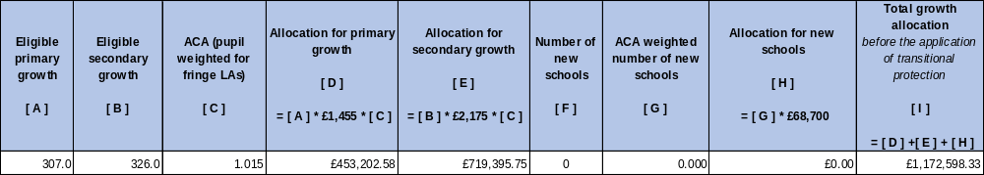

- It should be noted that the Department for Education do not expect local authorities to use these rates in their local arrangements for funding growth.

- Below is a provisional list of schools identified as likely to be eligible for growth funding in 2021-22.

School/Academy | Change / Reason for Growth | New School Opening Date / Date of PAN increase | No of additional places @ Sept 21
Abbeywood | Increase from 180 to 210 roll through year groups | 01-Sep-21 | 30
Bradley Stoke | Primary Phase roll through up to 7 year groups | 01-Sep-15 | 30
Charlton Wood | Post opening setting up costs and reception class breach (intake est at 60). Roll through. | 01-Sep-19 | 30
Downend | Start Sept 15 increase from 210 to 240 ongoing - roll through provision | 01-Sep-15 | 30
Downend | Potential Yr 7 increase from 240 to 270 from Sept 21 | 01-Sep-21 | 30
John Cabot | Increase from 160 to 175 roll through year groups. | 01-Sep-17 | 15
King's Oak | Primary Phase roll through up to 7 year groups | 01-Sep-15 | 30
Lyde Green | Increase reception from 60 to 90 | 01-Sep-21 | 30
Manorbrook | Potential increase 60 to 90 | 01-Sep-21 | 30
Watermore | Increase from 30 to 60 Reception - roll through to Sept 2025 | 01-Sep-19 | 30

Schools Specific Contingency

- Current school funding regulations are set out in the Financing of Maintained Schools Regulations 2015 which have provision for LAs to establish a Schools Specific Contingency, from its DSG funding for expenditure in relation to:

- Schools in financial difficulty,
- New, amalgamating or closing schools,
- Circumstances which were unforeseen when the schools budget share was initially determined

- A contingency was established in 2017-18 which will continue into 2021-22 and on an ongoing basis as previously agreed by the forum. The ability to access this funding by a school deemed to be in financial difficulty is very tightly controlled and in accordance with the following criteria:

Firstly, a licensed deficit should be considered and only when a school cannot produce a recovery plan within the licensed deficit criteria and falls into one of the categories below would additional assistance from the Schools Specific Contingency be considered:
  - School is in Special Measures
  - School is in Notice to Improve/Serious Weaknesses/Causing concern
  - End of key stage assessments below national for the last 3 years
  - Pupil progress in English and maths below expected levels
  - Ofsted judgement – Requires Improvement
  - Pupil number variations significantly outside of reasonably expected levels

- Schools are able to submit a case to the Head of Financial Management and Business Support who would make the decision to approve funding in conjunction with the Head of Education Learning and Skills and the Director of Children’s Adults and Health. A recommendation would then go to the Schools Forum to make a final decision to grant funding or not.

RECOMMENDATIONS
- The Schools Forum is asked to agree and approve policy change.
- Note this Report and agree criteria for the allocation of growth and schools specific funding in 2021-22.

Author
Mustafa Salih, Head of Financial Management and Business Support
Tel: 01454 863197

Departmental Contact
Michelle Palmer, Senior Finance Officer CAHC Department Tel: 01454 863207
South Gloucestershire Council

SCHOOLS FORUM

21st January 2021

Dedicated Schools Grant 2020/21 Quarter 2

Purpose of Report

- To update the School Forum on the Dedicated Schools Grant 2020/21 Quarter 2 position and DSG Recovery plan.
- Dedicated Schools Grant (DSG) Funded budgets

- The net current DSG budget, excluding academies and High Needs recoupment, is £139,444k. The DSG is forecasting an outturn overspend position of £24,465k. This arises from an in-year forecast outturn overspend of £8,118k compared to £8,254k at Quarter 1 and a brought forward deficit balance of £16,347k. Details of the key pressure areas are included in the block summaries below.
- It should be noted that when the budgets for 2020/21 were prepared, a funding shortfall of £7,754k was identified before applying the DSG recovery savings target of £2,813k. The forecast overspend makes an assumption that the in-year DSG savings target is unlikely to be achieved. This is due to the impact of Covid-19 as well as delays in implementing new working practices and alternative methods for delivering high needs services (Paragraph 87)
DSG Budget | Net  £’000
Original Budget Allocation (December 2019) | 219,189
Adjustments and Recoupment
- High Needs Block Direct Funding By EFA | -5,178
- Academy Recoupment | -74,944
- High Needs Block Adjustment for place change return | -147
DSG Announcements (July 2020)
- Early Years Block January 2020 census | 327
- High Needs Block import/export and free schools funding | 197
Total Revised DSG (July 2020) | 139,444

- The overspend position by funding block is provided in the table below.
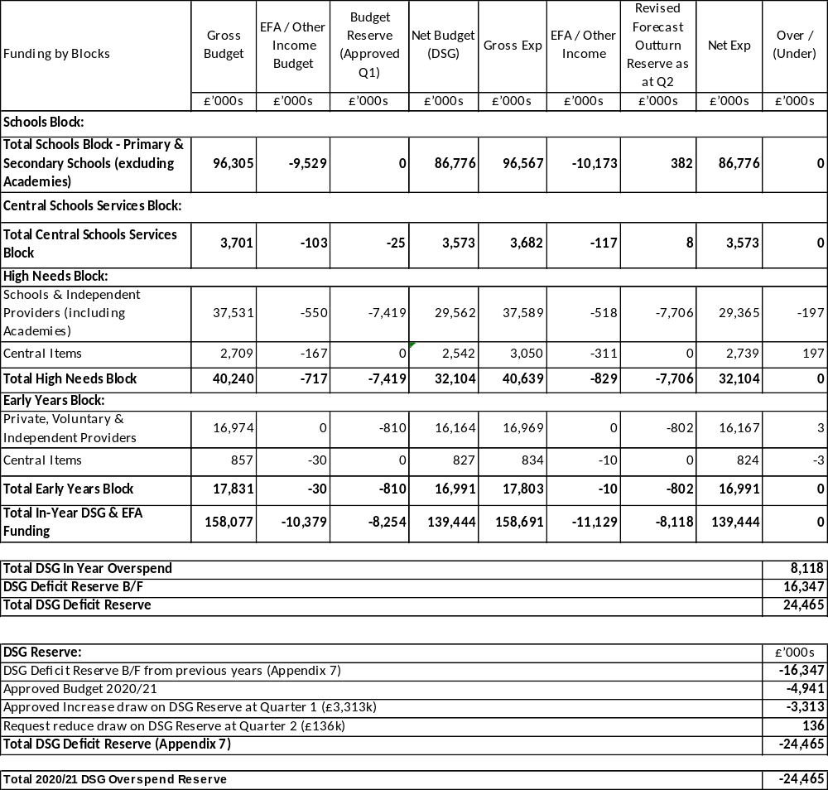

Funding Transfer between Blocks

- The DSG is funded from four blocks: The Schools Block, the Central Schools Services Block, the High Needs Block and the Early Years Block.
- There was a funding transfer of £2,200k approved by the Secretary of State from the Schools Block to the High Needs Block to support demand led pressures. This funding has targeted Special Schools, Independent and Non-Maintained Special Schools and Post 16 Placements.
DSG Recovery Plan

- The CAH department is committed to reducing the DSG overspend through more efficient ways of working which will positively impact on children’s outcomes and reduce expenditure in this area. Although activity within the agreed deficit recovery plan is starting to have an impact, the scale of the challenge means that it will take longer to deliver the targets than originally anticipated and planned. The department also recognises that this requires capacity at various levels to drive and support the change and this capacity is being created through a review of the current staffing structure with changes implemented in the autumn term. Over the last 12 months the department has created the infrastructure across South Gloucestershire to support delivery of key strategies, for example the SEND Support Cluster, which will make a significant contribution to improving local arrangements and have a positive impact on the financial position. Once the new staffing arrangements are in place the department will aim to accelerate progress in the delivery of the changes required and savings targets to be achieved.
- The High Needs Officers Working Group have not been able to meet for several months due to other work related demands linked to Covid-19. Regular meetings have recently commenced and the group will be revisiting the DSG recovery plan. The plan will need to be reviewed in partnership with School Leaders High Needs Working Group.
- A revised recovery plan, with updated targets for key pressure areas will be produced and presented to Schools Forum in January 2021 and Cabinet in February 2021. The revised recovery plan will take into consideration the indicative increased funding from the 2021/22 provisional funding announcement by Government in July 2020 of £3,518k
- The DfE has recently confirmed a change in its approach to DSG deficits. All DSG overspends are to be recovered solely from DSG income and with no set timescale for the length of this recovery process.
Schools Block

- The Schools Block is forecasting an outturn underspend of £382k, an increased underspend of £382k since Quarter 1. This is due to the growth funding for schools not being fully required in 2020/21. Growth funding is held within the Schools Block and supports permanent and temporary pupil growth within South Gloucestershire schools.
Central Schools Services Block

- The Central Schools Services Block is forecasting an outturn underspend of £33k, an increased underspend of (£8k) since Quarter 1.
High Needs Block
- The High Needs Block is forecasting an outturn overspend of £7,706k before applying the approved reserve transfer, an increase of £262k since Quarter 1. The over spend includes the assumption that the in-year DSG deficit recovery plan savings target (£2,813k) will not be achieved (paragraph 83). The main pressures within high needs areas are provided below.
Independent and Non-Maintained Special School Placements

- Independent and Non-Maintained Special School Placements are forecasting an outturn overspend of £1,359k, a reduced overspend position of £293k since Quarter 1. This is due to 9 new placements resulting in a net increase of £208k, 14 leavers (£483k) and 15 cost of provision changes (£18k). The budget required for 2020/21 was £7,604k based on 132 placements at an average weekly cost of £1,516, however based on the funding available the budget provided was £5,840k resulting in an average weekly cost of £1,164. The forecast outturn is based on 113 current learners and a provision for 12 new placements from September to March 2021 (3 planned placements £139k and 12 unplanned £245k) at an average weekly cost of £1,515. There are 2 learners with expected end dates of July 2020 where costs have been forecast to the end of the financial year as there is currently no forecast in Post 16 or alternative provision for these learners. The additional 7/12ths costs of the 2 learners is £58k. The 0-25 team are reviewing these learners and will update Cabinet with the students’ future provision at Quarter 3.
Statemented Support (including Other Local Authority (OLA)
- Statemented Support is forecasting an outturn overspend of £3,250k, an increased overspend of £491k since Quarter 1. This is due to 68 new provisions resulting in a net increase of £361k after offsetting the contingency for new plans,15 young people transferred from early years costing an additional £42k compared to the estimate, a contingency provision of £21k added for 4 future early years transfers, the transfer of young people from matrix to the Ready Reckoner through the Key Stage transfer process has cost an additional £14k, the September pupil transfers have cost an additional £57k, changes to a young person’s provision via the annual review process cost £101k, there is a reduction improvement of £54k for service leavers during August, compared to the original forecast and there was an increase in the high needs block funding of £51k.
- The budget required for 2020/21 was £7,131k based on 811 placements at an average weekly cost of £231, however based on the funding available the budget allocated was £4,635k resulting in an average weekly cost of £150. The forecast outturn is based on 796 current learners and a provision for 78 new placements from October to March 2021. The average weekly cost based on 874 placements is £239.
- In February 2019 the Ready Reckoner (RR) system was implemented for all new Education, Health and Care plans. It was intended that the RR would be rolled-out in 2020/2021 via the Annual Review Team for children transition across key stages. However, Covid-19 has impacted on the roll-out plan, which is now being reviewed. This work will be incorporated in the review of the Deficit Recovery Plan identified at paragraph 87 above with a view to accelerating the move to more consistent and transparent financial arrangements and corresponding financial benefits.
Special Schools and Resource Bases - OLA

- Special Schools and Resource Bases - OLA is forecasting an outturn overspend of £438k, a reduced overspend of £31k since Quarter 1. This is due to 9 new placements costing £89k, 9 leavers (£119k) and 1 cost of provision change (£1k). The budget required for 2020/21 was £1,399k based on 68 placements at an average weekly cost of £541, however based on the funding available the budget allocated was £865k resulting in an average weekly cost of £335. The forecast outturn is based on 70 placements made up of 64 current placements and a provision for 6 new placements October to March 2021 at an average weekly cost of £543.
Post 16 Placements

- Post 16 Placements is forecasting an outturn overspend of £100k, a reduced overspend position of £260k since Quarter 1. This is due to 14 new starters and 12 leavers resulting in a net cost reduction of £152k, 27 placements were the cost of provision has changed (£48k) and a reimbursement of Element 2 funding from City of Bristol College which is now funded directly from Bristol City Council (£60k).
- The budget required for 2020/21 was £3,247k based on 271 placements at an average weekly cost of £315, however based on the funding available the budget allocated was £3,028k resulting in an average weekly cost of £294. The forecast outturn is based on 285 current learners and a provision for 11 new placements in an Independent Specialist setting and a net reduction of 10 placements in FE College for September to March 2021. A list of the September 2020 learner’s attending FE colleges is currently being finalised by the various colleges and the 0-25 team. In addition there are currently 19 learners with expected end dates of July 2020 where the costs have been forecast for an additional year. The cost for September to March is £348k. An update on the students’ future provision and the confirmed September FE College placements will be provided at the 3rd Quarter revenue report.
Special Schools South Gloucestershire

- Special Schools is forecasting an outturn overspend of £992k, an increase of £219k since Quarter 1. This is due to 26 new starters and 24 leavers resulting in a net reduction of £32k, breach payments costing £62k, changes to cost of provision (£11k) and a funding adjustment for post 16 income and free schools allocation resulting in a net cost of £200k. The Post 16 income was forecast to be received directly from the Education and Skills Funding Agency (ESFA) in line with previous year, however from September the ESFA has included this as part of the high needs block funding £346k. The additional income of £146k relates to funding based on lagged pupil numbers for SGS Pegasus Special School.
- The budget required for 2020/21 was £9,477k based on 513 placements at an average weekly cost of £486, however based on the funding available the budget allocated was £8,575k resulting in an average weekly cost of £440. The forecast outturn is based on 483 current learners plus a contingency for 22 new starters giving a total of 505 learners at an average cost of £498 per week.
- The local authority plans to increase local provision and reduce reliance on Independent and Non-Maintained Schools as part of the DSG recovery plan. In 2020/21 the local authority has increased the number of placements in South Gloucestershire Special Schools by 61 places. The increased places from September 2020 are within SGS Pegasus +27, New Horizons Special School +14 and Warmley Park +20 (including a nursery provision). The increased provision is included within in the forecast outturn figures using an average top up band for each Special School. Once places have been filled, the actual band allocated against each learner will be updated.
Resource Bases South Gloucestershire

- Resource Bases are forecasting an outturn overspend of £373k, an increased overspend position of £79k since Quarter 1. This is due to 14 new starters and 5 leavers resulting in a net cost of £32k, breach payments of £29k, increases to the cost of provision (£6k) and 1 young person moving to South Gloucestershire (£12k).
- The budget required for 2020/21 was £2,632k based on 132 placements at an average weekly cost of £525, however based on the funding available the budget allocated was £2,423k resulting in an average weekly cost of £483. The forecast outturn is based on 137 current learners plus contingency for 4 new starters giving a total of 141 learners at an average cost of £522 per week.
Pathways Learning Centre

- Pathways Learning Centre (PLC) is forecasting an outturn overspend of £1,644k, a reduction of £2k since Quarter 1. The budget required for 2020/21 was £2,720k based on 218 placements at an average weekly cost of £328, however based on the funding available the budget allocated was £1,848k resulting in an average weekly cost of £223. The forecast outturn is based on actual payments up to the end of September 2020 and a forecast for October to March 2021 based on a new funding agreement between the Head of Education Learning and Skills and Pathways Learning Centre. From September 2020 funding for PLC is based on a fixed number of placements per annum and top up funding rates based on previous years averages. It should be noted that PLC is supporting several young people with Education, Health and Care Plans (typically 30-40) whose needs are not currently being met in South Gloucestershire Mainstream, Special Schools, and Resource Bases and in some cases other OLA Special Schools due to the complexity of these young people. It is reasonable to assume that many or all of these young people may have been placed in a high cost Independent Specialist provision, if PLC were not available.
Other High Needs Areas

- Other high needs areas are forecasting an outturn underspend of £426k, a reduced underspend position of £58k since Quarter 1. This is mostly due to 3 new support packages for young people currently not in an educational setting costing £56k and other small changes of £2k.
- The table below shows the outturn spend position for the High Needs budget areas that are currently under pressure.
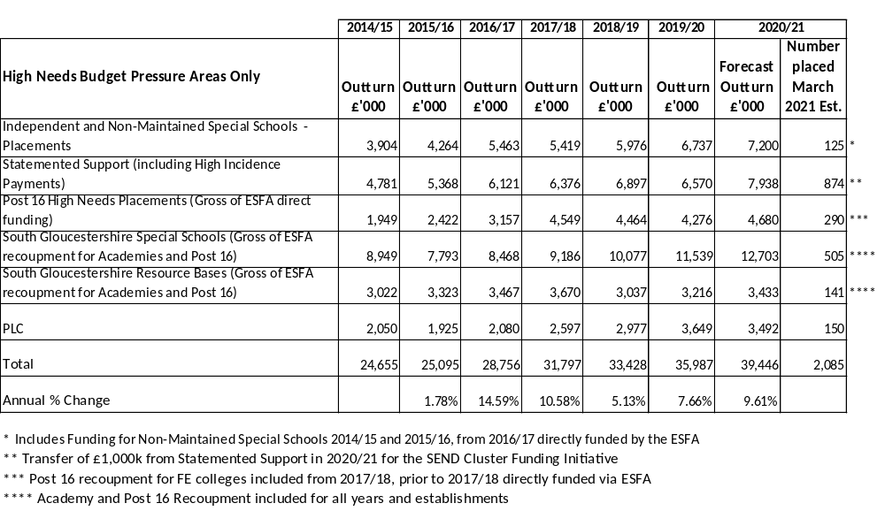

- Pressure on the above demand driven High Needs areas has increased mostly due to a delay in the implementation of the SEND Cluster Fund and the opening of Pegasus Special Free School.
- The SEND Cluster Fund was originally planned to be ready for full implementation across the local authority by April 2019. Due to the innovative nature of this project, which requires significant partnership working between schools and the local authority, it took longer than anticipated to establish the original two pilots and roll out to all schools. The 6 clusters are now fully established and operational.
- This will have a positive impact on the number of pupil exclusions referred to Pathways Learning centre (PLC) and the escalation of needs for pupils at SEND Support level during 2020/2021.
- The opening of Pegasus Special Free School was delayed by a year due to problems incurred during the building process which was led and funded by the Education and Skills Funding Agency. This impacted on the department’s plans to place young people locally and reduce the number of young people being placed out of area. When a new school opens, pupils are phased in over several years to ensure the correct skill sets and facilities are fully embedded to meet future demand. In 2019/20 the school was supporting pupils with very complex needs and the number it could admit was limited and also a year behind the department’s original plan. The place capacity will increase over the coming years which will ensure the school grows at a pace that can adequately support the predicted growing pupil numbers with complex need. In September 2020 the schools capacity has increased by 27 places.
Early Years Block

- The Early Years Block is reporting a forecast outturn overspend of £802k, a reduced overspend position of £8k since Quarter 1. The overspend position is due to a shortfall in funding for 2018/19 and 2019/20 academic years. Local Authorities are funded for 38 weeks a year based on the number of entitlement hours submitted on the annual census return. However, Nursery settings and providers are permitted to stretch their entitlement hours over more than 38 weeks should they wish. An investigation has taken place and found that nursery providers have been able to allocate the entitled 15 hours per week over 48 weeks resulting in the census hours being submitted as 11.88 hours instead of 15 hours. The local authority has therefore been funded on 11.88 hours over 38 weeks instead of 15 hours over 38 weeks. A working group has been set up and actions are being put in place to ensure the census data collected for January 2021 is not based on stretched hours. Training will be offered to nursery providers on how to input the census return data. A request has been be put forward for the Early Years Portal system to be fixed at 38 weeks and the guidance notes are being reviewed.
- The department has been in contact with the Education and Skills Funding Agency (ESFA) to notify them of the error on the census returns and asked if an amendment can be made to the original claims. Unfortunately to date these requests have been denied.
- In addition to the existing Early Years Block pressure identified above it is anticipated that some settings may not receive the same level of take up as in previous years, due to parents working at home and parental concern over safety due to the impact of Covid-19. The ESFA is recommending local authorities fund early year’s settings at the same level as Autumn Term 2019 to make sure settings don’t lose funding and ensure sustainability. The ESFA is also proposing to fund Local Authorities based on the January 2020 census date of which the council’s census included an error (paragraph 113). Colleagues from the Department for Children Adults and Health and Corporate Finance met with ESFA representatives on 22nd October 2020 to discuss the current Autumn Term 2020 funding proposal for Early Years settings and Local Authorities and raised concerns over the financial impact for South Gloucestershire in 2020/21 as well as the previous year’s census discrepancies (paragraph 113). The ESFA have taken the council’s comments on board and is currently looking into the concerns raised. Whilst this may not result in an amended claim for previous years, they may agree to amend the Autumn Term 2020 funding. The outturn figures do not include the potential shortfall and an update will be given to Cabinet in the 3rd Quarter monitor report.
- On 20th October Schools Forum were presented with the latest position on the Early Years Block and asked to support the following recommendations which were approved.
- Firstly the local authority can top slice 5% of the Early Years Block to support central services for Early Years. The Department is proposing to offset any financial increase in the 5% retained in future years to repay this deficit. This is likely to take in excess of 10 years due to the size of the deficit and was approved by Schools Forum.
- Secondly it is likely that not all of the initial growth funding commitments for 2020/2021 will be required. Schools forum are asked to consider any underspend in the schools block be used to offset the in-year deficit in the Early Years Block. Schools Forum approved this proposal. The current forecast for this area is an underspend position of £382k (paragraph 91).

- Recommendation
- The Schools Forum to note the Quarter 2 report and figures.

Early Years Funding Consultation

2021-22

Introduction
In line with government requirements, South Gloucestershire Council is consulting on proposals for the funding formula for 2, 3 and 4 year old children in settings to be implemented from April 2021. Schools Forum will be consulted on funding changes following consultation with the sector, with the final decision resting with the local authority.

The information contained in this report is accurate at the time of being written, however it might be subject to change depending on government announcements.

South Gloucestershire will receive a £0.08 increase for 2 year olds and £0.06 per hour for 3 and 4 year olds. 5% will be retained to provide central services to the sector, whilst the remaining 95% will be passed through to the sector through:

2 year old rate base rate

3-4 Year old base rate

Inclusion Fund

Deprivation Supplement

Flexibility Supplement

Contingency Fund.

The Sector are being asked to select 1 or 3 different options for implementation in March 2021. Practitioners are urged to consider the implication of each option very carefully in making their selection, drawing upon the information provided.

2 year Old Funding.
This is the standard hourly rate which is paid to all settings who claim funding for 2 year olds. The rate is the same regardless of the number of hours claimed up to the maximum of 15 hours per week.

For 2021-22 the funding rate will be decided depending on the option selected below.

3 Year Old Funding Base Rate
This is the standard hourly rate which is paid to all settings who claim funding for 3 and 4 year olds. The rate is the same regardless of the number of hours claimed up to the maximum of 30 hours per week.

For 2021-22 the funding rate will decided depending on the option selected below.

These will remain the same in each option.

Inclusion Fund (Mandatory)
The Inclusion Fund has been set up to enable settings to apply for additional funding to meet the needs of children who have SEND but who are not undergoing a needs assessment or are in receipt of an EHCP. Since the inception of the Inclusion Fund the numbers of children with SEND and the pressures facing settings have continued to increase.

The Inclusion Fund will remain at 2% of the hourly rate to enable settings to continue to meet the needs of children with SEND.
Deprivation Supplement (Mandatory)
The deprivation supplement is paid in a lump sum to providers alongside their regular payments. The purpose of the fund is to enable settings to provide targeted support to reduce the significant impact economic disadvantage has on children’s development and attainment, which can affect their life chances. The allocation of the deprivation fund is based on the number of universal hours taken up by Early Years Pupil Premium children in a setting. This decision was made to ensure the payments reach the most disadvantaged children and will remain in place for 2020-21.

The Deprivation supplement will remain at 0.9% for 2021.

Flexibility Supplement (Discretionary)

Since the introduction of the revised funding formula in 2017, childminders have received a flexibility supplement to ensure that they do not take a reduction in their hourly rate. The Local Authority are concerned that any reduction in the childminders hourly rate would see a loss to the childminding community as they may no longer be able to afford to take funded children.

The flexibility supplement in will remain at £0.14.

New - Contingency Fund – Variable according to the option selected.
The Local Authority acknowledges the challenges facing the sector during this time of a national pandemic. Information provided by the government in December 2020, indicates that settings will be paid based on the number of children attending the setting at the time of the January Early Years Census. Estimated numbers for January 2021 were still below January 2020 estimates, before the impact of entering another national lockdown, however attendance may well increase as the year progresses and lockdown eases to normal levels. It is with this in mind, the Local Authority are proposing to allocate some funding to create a Contingency Fund to support the anticipated increase in children attending settings as the year progresses. The creation of such a fund is in line with the Early years entitlements: local authority funding of providers Operational guide 2021 to 2022.

Based on current available information, it is indicated that approximately £240,000 would be required in this contingency fund to cover the anticipated difference between the funding provided to the local authority based on census data and the actual amount that will be paid to the sector.

Option 1

This option does not include any funding allocated to the Contingency Fund and provides base rates of £5.31 for 2 year olds, an increase of £0.08 and £4.12 for 3-4 year olds an increase of £0.05.

In selecting this option, settings will have a significant increase to their hourly rate. Within this option, there is a significant risk there will be insufficient funds should numbers of children attending settings in the summer term increase. This may result in the budget being in deficit at the end of the year. Any deficit would need to be recovered from future years funding settlements. This may result in a reduced hourly rate in the future. Settings are urged to consider if they would like the full amount now and then potentially have a reduction in future years or if one of the other options would provide longer term stability in their hourly rate.
Option 2
This option creates a contingency fund of £100,000, which is less than half of the anticipated amount required should take up of hours attended return to normal in the summer term. Opting for this would create an hourly rate of £5.28 for 2 year olds, an increase of £0.05 and £4.10 for 3-4 year olds, an Increase of £0.03.

Increasing the hourly rate by this amount would enable settings to cover the increases to the minimum wage. This option would also reduce the possible deficit which would have less impact on future years when compared to option 1. Any deficit would need to be recovered from future years funding settlements, however this is unlikely to result in a further cut in the rate and the £0.03 increase is likely to be sustainable. Whilst there is likely to be an impact on future years within this option, this is likely to be less significant than Option 1.

Option 3
This option creates a fund of £219,155, which is closer to the anticipated amount required. The hourly rate for 2, 3, or 4 year olds remain at £5.23 and £4.07 respectively.

In selecting this option, the risk of having a significant deficit at the end of the year would be reduced, however there would be no increase to the annual rate for this year. Any deficit would still need to be recovered from future years funding settlements and therefore may affect any increases in future hourly rates.

Breakdown of the options

 | Option 1 | Option 2 | Option 3
Contingency Fund | £00.00 | £100,000 | £210.412
2 year Old Rate | £5.31 | £5.28 | £5.23
3 -4 year Old Rate | £4.12 | £4.10 | £4.07
Flexibility supplement for childminders | £0.14  £4.26 | £0.14  £4.24 | £0.14  £4.21
Inclusion Fund  Indicative amount | 2%  £290,000 | 2%  £290,000 | 2%  £290,000
Deprivation Fund  Indicative amount | 0.9%  £134,000 | 0.9%  £134,000 | 0.9%  £134,000

Things to consider
In the current situation, it is highly likely numbers of children attending settings in January is lower than normal as this is significant in January as the local authority receives funding based on the January census. Therefore, the anticipation that summer term will be closer to normal will create an unfunded deficit budget. Consideration should be given to the impact this might have not just this year, but in future years’ as the deficit is paid back.

The Timeline

The Sector will be consulted in the following ways:

- Meetings with the Early Years Working group and School Forum representatives
- Providers will be emailed the consultation paperwork and link
- Information/links to key documents and publications posted on the VLE for all providers

The timescale of consultation activities is as follows:

Timescale | Activity
January 2021 | Initial consultation with the Sector  Deadline for responses 3pm Thursday 14th January 2021
January 2021 | Report sent to Schools Forum and CAH Committee
March 2021 | The sector will be informed of outcome of consultation
April 2021 | Implementation of new funding formula

How to respond
Responses to the consultation can be made through the VLE only and must be received by 3pm on Thursday 14th January 2021.
To complete the survey, xxxxxxx
Please note, only one response per provider will be accepted.

Contact information
Rachel Webb
Senior Education Adviser (Early Years Manager)
01454 863359
Rachel.webb@southglos.gov.uk

South Gloucestershire Council

SCHOOLS FORUM

21 JANUARY 2021

INTERNAL AUDIT INFORMATION - ACADEMIES

Purpose of Report

1. The purpose of this report is to:
(i) Provide Schools Forum with details on any key findings or recommendations from the internal audit services utilised by those Multi Academy Trusts (MAT) with academies in South Gloucestershire.
(ii) This report is for information only.

Background

2. During 2019/20, a paper was provided to Schools Forum detailing key findings from the internal audit services provided to maintained schools by South Gloucestershire Council. Six MATs were contacted to collate relevant feedback on the internal audit service provided to them during the 2019/20 academic year. The total number of academies included in this paper are:

Schools | 43
Students | 23,458

A summary of the key points is detailed below.

Areas Audited
3. Overall, MATs utilised a range of approaches for identifying areas of focus for internal audit from a risk-based approach to prioritising based on need/change in legislation. The areas that were audited by the MATs during 2019/20 included:
- Income
- Purchasing (including fraud)
- Financial Planning & Budget Management
- Financial Procedures and Policies
- Estates Management and Capital Projects
- Academies Financial Handbook compliance
- HR: strategic, admin and payroll
- Staff Recruitment
- IT Data
- Strategic Planning
Recommendations
4. The majority of audits were completed with only minor recommendations. Those worthy of note for the purposes of informing Forum are:
- Consider developing detailed payroll procedures that could include IT protocols, operations, responsibilities, inter-dependencies and risks and controls.
- The Trust reviews its Financial Procedures and Policies on a regular basis.
- Capital projects should have a final review and reviewing what lessons have been learned.
- Business continuity and disaster recovery plans should be documented.
- Detailed IT change management processes should be documented

Summary

5. MATs are required to have a detailed internal audit function each year as directed by the Academies Financial Handbook. The annual internal audit report is provided to the ESFA for review and comment.
Most MATs had managed to meet their internal audit requirements satisfactorily but had to delay some areas due to the pandemic.

South Gloucestershire council
SCHOOLS FORUM
21st January 2021
High Needs Working Group (HNWG) Update

Purpose of Report

- The purpose of the report is to provide an update on the work of the HNWG.

Background

- The work of the High Needs Working Group (HNWG) will continue into 2020-21 Academic Year.

- Members of the group have all committed to quarterly meetings to ensure there is a close link between the aims of the HNWG and the overarching SEND strategy, which is determined by the Local Authority, led by Hilary Smith. The last meeting was moved into Term 2 (17.11.20), in line with the launch of the South Glos Way session.

- There are several key strands and workstreams as set out in the strategic plan. The following extract from the Terms of Reference outlines the six themes.

- The HNWG will monitor the work of South Gloucestershire’s High Needs SEND Strategy through the 6 themes identified:
- Improve local offer SEND support
- Improve access to high quality specialist provision within local area
- Develop capacity of workforce to deliver a consistently high quality response to CYP with SEND and a commitment to inclusive practice across all schools in South Glos.
- Effective Partnership across the Local Area for SEND
- Financial arrangements
- Ensuring sufficient capacity to drive and deliver change

- The HNWG is accountable to the Schools Forum.

- The HNWG will identify people within South Gloucestershire’s High Needs SEND strategy to report back on a regular basis.

Key priorities for Autumn 2020 and into Spring 2021

- Impact of the breadth of the SEND developments across the Local Authority

- SG Recovery curriculum development – linked to the #SGConnect work across the LA with schools working in close partnership across the sector – this is still crucial as we head into a third National lockdown.

Across the team within South Glos have been reviewing the key statistical data regarding SEND in South Glos, which formed a key part of the presentation to the Autumn meeting and is being used to inform the Local Authority SEND strategy moving forward. Current considerations and areas of focus include effective use of benchmarking, the next impact of and next steps in terms of the Ready Reckoner and looking at options for top-up banding systems, linked to the developments with the ready reckoner.

Previous HNWG updates to the Forum

- Headlines from previous meeting – November 2020

DSG Funding – a whole system approach

The meeting in November comprised of a full presentation led by Karina Kulawik and Kate East and picked up the key themes as outlined in the HNWG strategic plan.

The areas of focus were as follows:

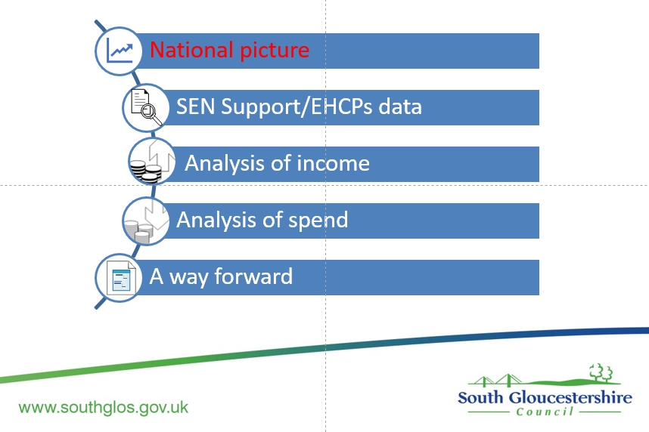
As previously noted in the most recent update to the Schools Forum, there was a focus on benchmarking.
There was a good opportunity for discussion and challenge and to focus on the previously identified areas that require further scrutiny, analysis and action across the Local Authority.

At the last HNWG meeting in November we looked at the key area of high needs spend across the Local Authority.

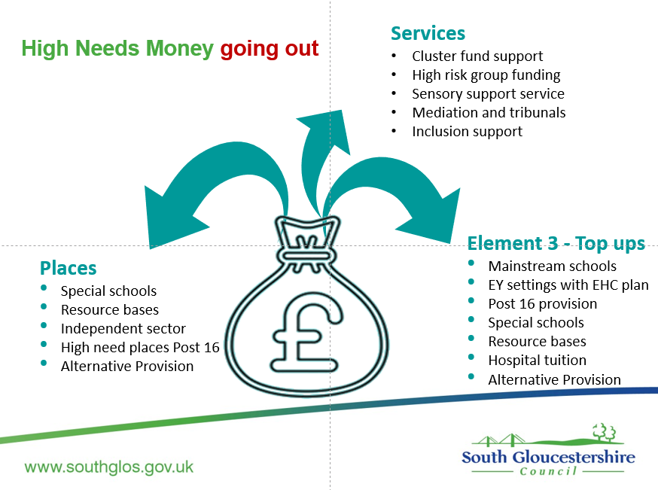

- The next scheduled HNWG meeting is now booked for 28th January 2021.

- Agreed Themes for further meetings are the following:

- For future discussion and debate
- Questions around placements require much more analysis, not just in the independent sector but also in sufficiency planning and special schools with the age ranges covered
- Questions around what has been observed in the data that our patterns in SG are different than many other LAs.

Agreed Themes for focus are the following:

Theme 1: Early intervention, SEND Support and meeting the needs of CYP in South Glos. Schools

Theme 2: Specialist Provision and the Independent Sector

Theme 3: Good Practice
- Update on new provision and place planning
- Cost of independent places
- Planning for QA on independent places

Theme 4: Partnership with other Agencies
- Update on progress of financial contribution from health

Theme 5 : Financial arrangements

Theme 6: Ensuring sufficient capacity to drive and deliver change

Additional items to carry forward:
- Ongoing – review of the work of SEND clusters
- QA on independent places

Further updates

- Further work is underway to make the best use of the DfE Schools Benchmarking for High Needs funding tool including further examination and analysis to support the HNWG and Schools Forum planning and to inform the cost benefits analysis for the coming year.

- In addition, the HNWG will continue to work in close partnership with RT (Chair of Parent/carer forum) and team to ensure the voice of the child and parents/carers is clearly articulated through the HNWG to ensure full and fair representation.

RECOMMENDATIONS
- None

Report Author

Susie Weaver

FORWARD PLAN

March | 25th | 1 | Deficit Recovery Plan | Mustafa Salih
 |  | 2 | DSG/High Needs block transfer | Mustafa Salih
 |  | 3 | Budget Approval update | Mustafa Salih
 |  | 4 | HNWG update | Susie Weaver

All future meetings will be held on Microsoft Teams until further notification from the Forum Chair.

FUTURE DATES

2021
25 March
13 May
8 July

ANY OTHER BUSINESS

