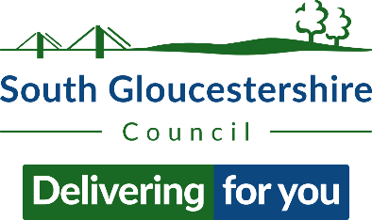

Acceptance of the 2023/24 Retail, Hospitality and Leisure Relief Scheme form (Form A)

Fields marked * in bold are mandatory

Fields marked ** in bold are mandatory if declaring no subsidy in the respective table above

Non-Domestic Rates Account Number: [insert billing number]*
Hereditament: [insert address of property you are seeking relief]*

By accepting Retail, Hospitality and Leisure Relief on the above hereditament I am confirming that [name of ratepayer]* (together with any other companies in the same Group) shall not receive more than £110,000 of the Retail, Hospitality and
Leisure Relief Scheme for eligible properties within 2023/24 and shall not receive
more than £315,000 in total of Minimal Financial Assistance over 3 years (including
2023/24).

Find guidance on the cash cap and Minimal Financial Assistance limit
(https://www.gov.uk/government/publications/business-rates-relief-202324-retail-hospitality-and-leisure-scheme-local-authority-guidance).

List of RHL Relief in 2023/24

Value of RHL Relief | Property Reference No. | Local authority providing subsidy
£
£
£
£
£
£
£
£
Continue on a separate sheet if necessary.

By leaving this above table blank, I am legally declaring that [name of ratepayer]** (together with any other companies in the same Group) have received no Retail Hospitality Leisure Relief to date. I understand that any ratepayer who makes false representation in order to gain relief may be guilty of fraud under the Fraud Act 2006.
List of other Subsidies (excluding RHL relief for 2023/24)

Do list:
- Covid business grant(s) received from local government and any other subsidy claimed under the Minimal Financial Assistance or Small Amounts of Financial Assistance limit over the 3-year period

Do not list:
- Extended Retail Discount(s) granted in 2021/22

Value of other subsidies (2021/22 to 2023/24) | Property Reference No. | Local authority providing subsidy
£
£
£
£
£
£
£
£
Continue on a separate sheet if necessary.

By leaving this above table blank, I am legally declaring that [name of ratepayer]** (together with any other companies in the same Group) have not received any Minimal Financial Assistance or Small Amounts of Financial Assistance over the last three years (including 2023/24). I understand that any ratepayer who makes false representation in order to gain relief may be guilty of fraud under the Fraud Act 2006.

I confirm that:

1) I am authorised to sign on behalf of [name of ratepayer]*; and

2) [name of ratepayer]* (together with any other companies in the same Group) shall not by accepting this relief exceed the £110,000 cash cap limit for 2023/24 Retail, Hospitality and Leisure Relief Scheme or the Minimal Financial Assistance limit of £315,000 over three years (including 2023/24).

Signature*:
Name*:
Position*:
Business*:
Address*:
Date*:

