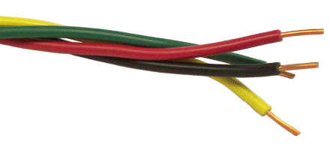**The Wire Project - application form**

For South Glos, Swindon, Wiltshire and Bristol Schools **Widening Inclusion in Religious Education**

This project seeks to encourage and support good practice in Religious Education.

Through rewarding:

* schools taking students on visits to places of worship
* schools where members of staff attend and benefit from further training through Religious Education CPD
* schools that go the extra mile in RE through entering a competition or putting on an RE related event during the school year

All these elements have to have taken place within an academic year (please attach or send evidence for each)

**Academic year: __________**

|  |  |
| --- | --- |
| Name of school |  |
| Address of school |  |
| Name of member of staff leading this initiative |  |
| E-mail address |  |

Please send this application form to [efpawson@gmail.com](mailto:efpawson@gmail.com)