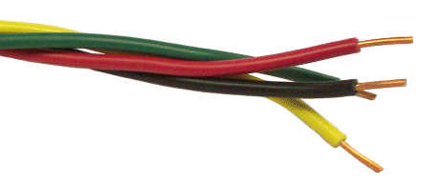**The Wire Award - Evidence Collecting Form**

Staff name

School

For **South Glos** Schools

**Widening Inclusion in Religious Education**

|  |  |  |  |
| --- | --- | --- | --- |
| **Element** | **Place / Event / Date** | **Signature of person / evidence[1]** | **Role of person/explanation** |
| 1. Visiting place of worship[2]  (this should be other than the majority faith represented in your school) |  |  |  |
| 2. Training event (CPD)[3] |  |  |  |
| 3. School based event - entering a competition[4] or putting on an event |  |  |  |

For further communication or support please contact [efpawson@gmail.com](mailto:efpawson@gmail.com)

1. For elements 1 and 3 please submit scanned evidence or photographs of 3 pieces of pupil’s work or a link to the school’s website where work can be viewed.
2. For suggested contacts for places of worship – see <https://beta.southglos.gov.uk/sacre/#religious-trips-and-visitors>
3. CPD opportunities may include conferences, [LTLRE hubs](https://ltlre.org/areas/region-2/) (termly – FREE!) or other RE curriculum training
4. <https://www.natre.org.uk> Spirited Arts or Spirited Poetry is a great National RE Art competition - evidence of entering this (not necessarily winning) is sufficient. Any other enrichment activity (exhibitions, interfaith events, drop-down days) also accepted.